Css part 2 Box model :

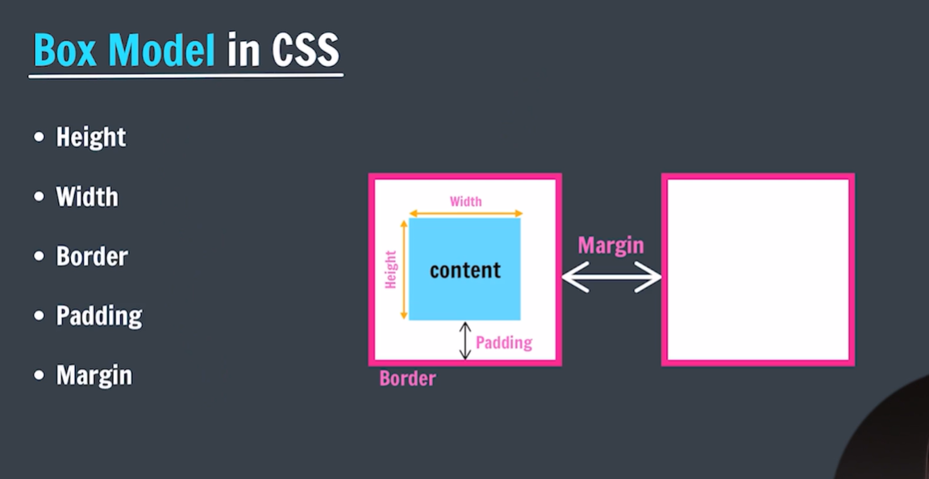

BORDER:

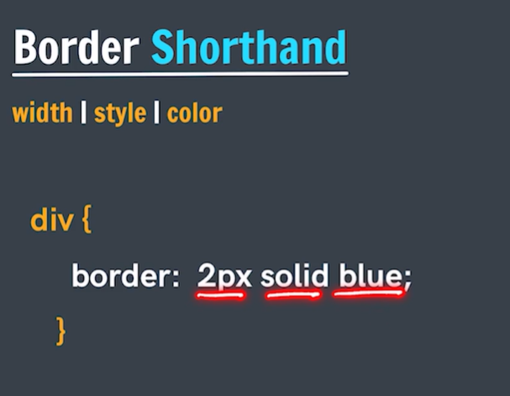

Padding :

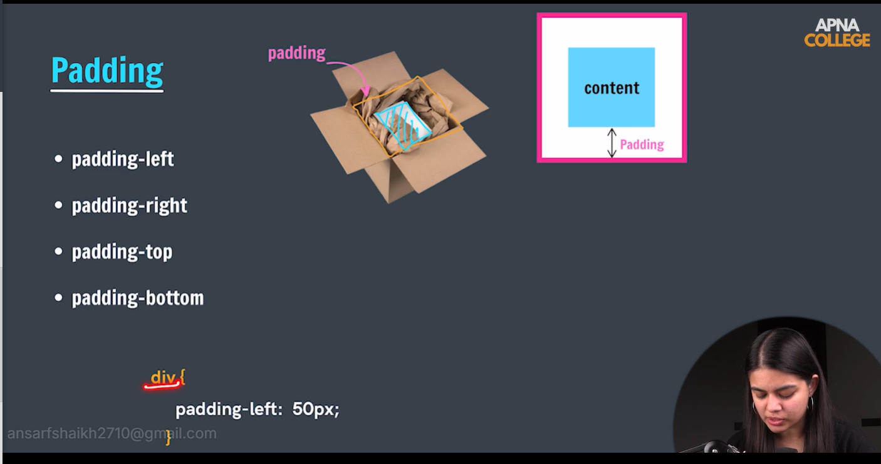

Short cut :

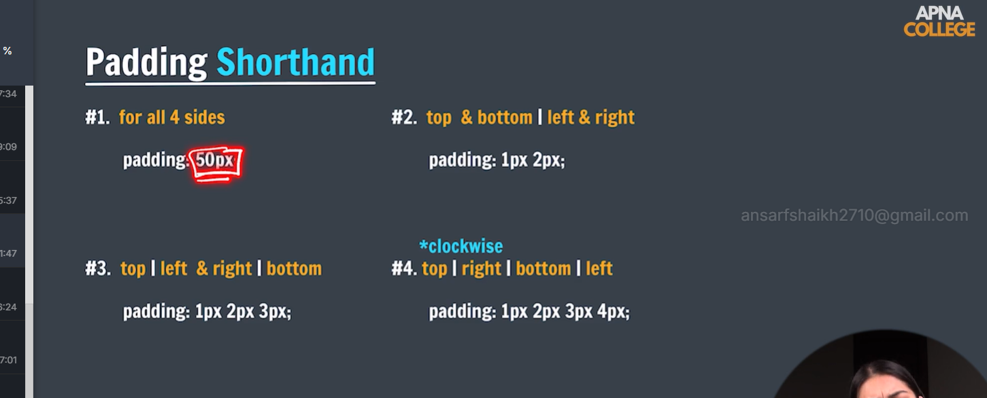

**Span tag :** Imp:

1. Don’t set height and width
2. Padding is always left and right not top and bottom
3. margin is always left and right not top and bottom

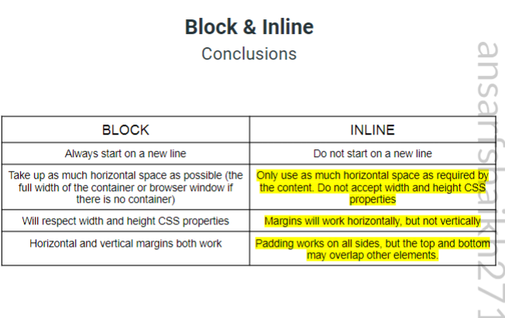

**MARGIN**:

For any box to set the centre we use margin :0 auto => imp

**Transition property:**

Transition:property name, duration ,transition function ,delay;